**4.5 SUPPLIER PAGE:**

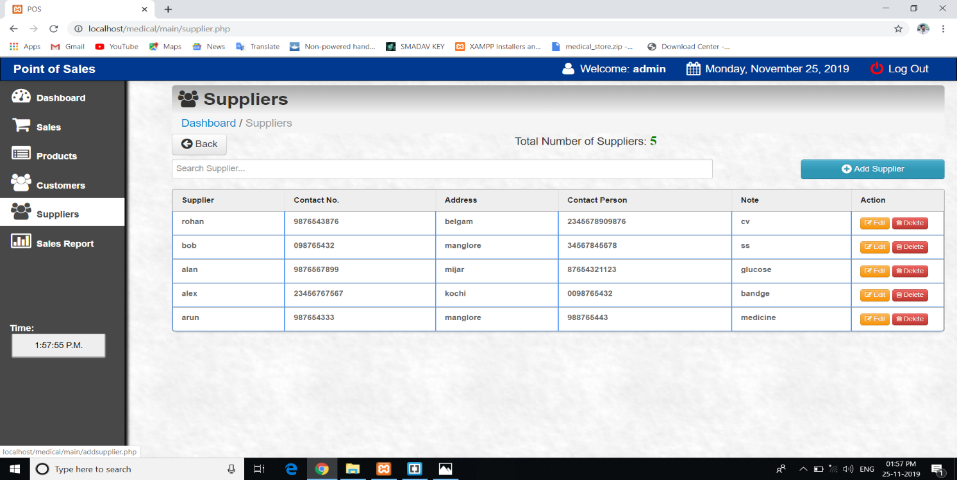**Fig 4.5: Supplier page**

**4.6 SALES PAGE:**

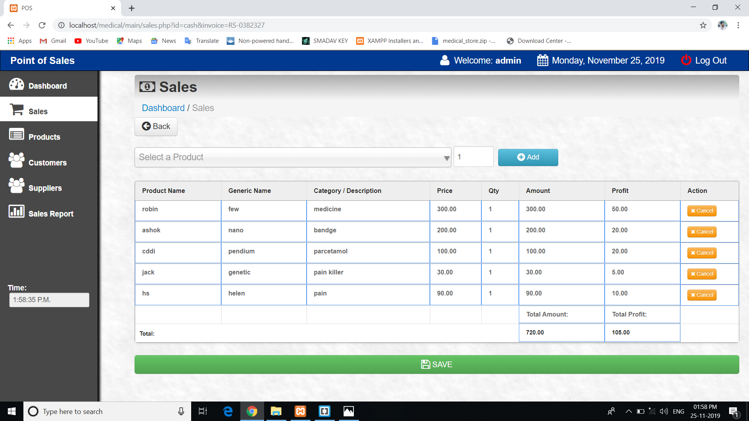

**Fig 4.6: Sales Page**

**4.7 SALES RECEIPT PAGE:**

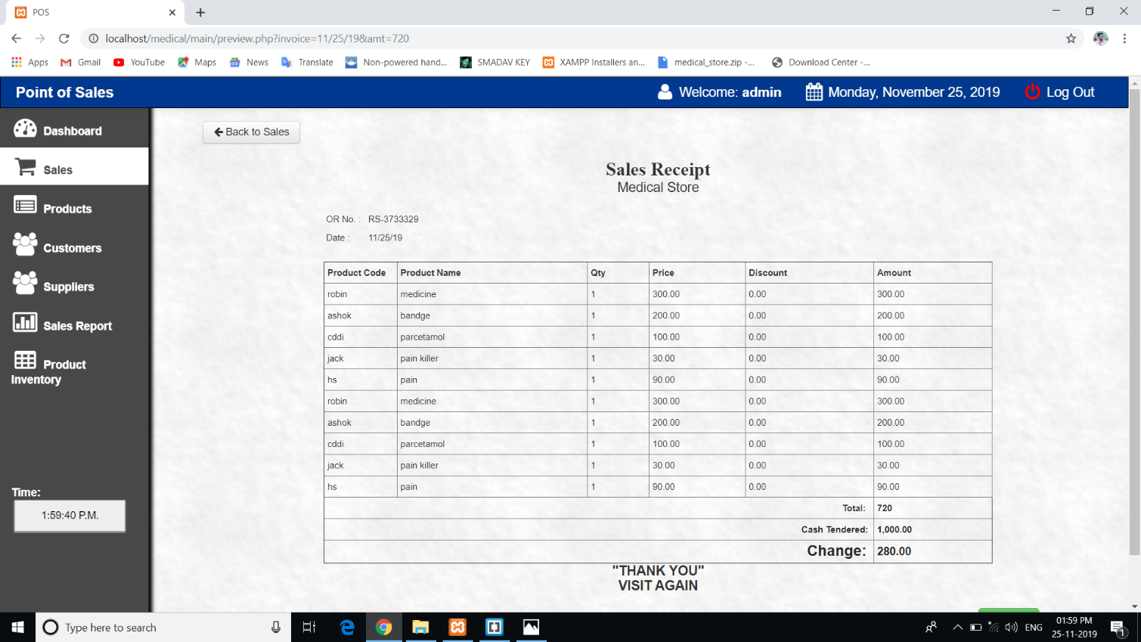

**Fig 4.7: Sales Receipt Page**